Contents
- Overview
  - Benefits
- Microservices
  - Explanation
- Virtual Rounding Settings
  - Configurations
  - View Configs
  - Application Features
  - Application Permissions
  - Dashboard Screens
  - Revision History

Overview
Virtual Rounding allows the rounding team (nurse or other hospital management) to initiate a virtual video session between the Participant (patient and guest) and Provider (Doctor). Interpreter feature is available for language translation.
Virtual Rounding provides a flexible and efficient method for healthcare providers to connect with patients remotely. It plays a crucial role in patient care by facilitating communication between care teams, patients, and their families. Healthcare systems are provided with a configurable experience allowing their staff to quickly identify and route virtual requests to on-shift and available providers. This transition to a virtual format leverages technology to maintain the essence of rounding while overcoming geographical barriers and optimizing time management.
There are two types of devices:

  - Mobile Device

  - Fixed Type Device

Benefits
- Various endpoints are integrated into a single dashboard, providing AI-driven notification for fall risk, elopement, and ambulation.
- Notifies on-shift care teams about on-demand virtual consultations.
- Captures patient self-reported data to guide actions for the care teams.
This documentation aims to explore the MicroServices, Workflow, Configurations, APIs, and best practices associated with Virtual Rounding functionality.

Microservices
- AndorHealth.Identity.Web.Api Service
- AndorHealth.User.Api Service
- AndorHealth.Patient-list.Api Service
- AndorHealth.Patient.Api Service
- AndorHealth.VirtualHealth.Api Service
- AndorHealth.MsTeams.Api Service
- AndorHealth.Tenant.Api Service
- AndorHealth.Pexip.Api Service

Draw.io link: https://drive.google.com/file/d/1uKepBioirwlPQb0IhOUz3Tq1mit0SLbw/view?usp=sharing

- The below diagram depicts how AndorHealth. VirtualHealth.Api Service interacts with the video service providers.
Draw.io link: https://drive.google.com/file/d/1kH_f036Ktxe-Kju_etJPDmwdDBXi1FbF/view?usp=sharing

Explanation
- Client UI/Frontend: This user interface layer interacts with the backend microservices.
- AndorHealth.Identity.Web.Api Service: Handles authentication and user identity management.
- AndorHealth.User.Api Service: Manages user-related operations.
- AndorHealth.Patient-list.Api Service: Deals with patient listing and other related operations.
- AndorHealth.Patient.Api Service: Provides patient-specific functionalities.
- AndorHealth.VirtualHealth.Api Service: Offers functionalities related to virtual health services like video calls.
- AndorHealth.MsTeams.Api Service: Handles integration or functionalities related to Microsoft Teams.
- AndorHealth.Tenant.Api Service: Manages tenant-specific operations, potentially accessed by other services like VirtualHealth.Api.
- AndorHealth.Pexip.Api Service: This endpoint allows AndorHealth to leverage Pexip's video conferencing capabilities within the platform.
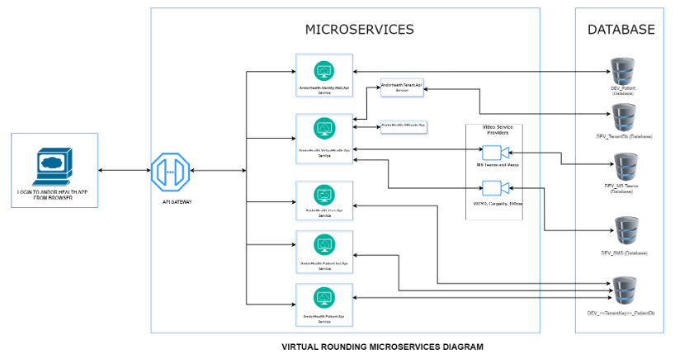
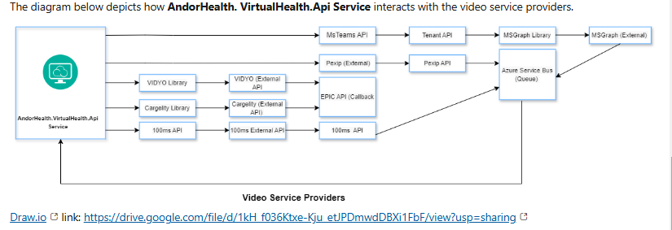

Virtual Rounding Settings
Click the below links to learn more about Virtual Rounding Settings.
- Configurations
- View Configs
- Application Features
- Application Permissions
- Dashboard Screens
- Revision History

